A Project Report
On
Traffic sign recognition system
submitted for partial fulfillment of the requirements
for the award of the degree of
Bachelor of Technology
in
Computer Science
Submitted by
Asish kumar(2000290120046)
Anubhav kumar(2000290120032)
Prashant Gupta(2000290120111)
Under supervision of
Prof. Pawan kumar pal

KIET Group of Institutions, Ghaziabad
Dr. A.P.J. Abdul Kalam Technical University, Lucknow
DECLARATION
I/We hereby declare that this submission is our own work and that, to the best of our knowledge and belief, it contains no material previously published or written by another person nor material which to a substantial extent has been accepted for the award of any other degree or diploma of the university or other institute of higher learning, except where due acknowledgment has been made in the text.

Signature
Name:- Asish Kumar,Anubhav kumar,Prashant Gupta
Roll No.:- 2000290120046,2000290120032,2000290120111
Date:- March 10, 2024

CERTIFICATE

This is to certify that Project Report entitled “Traffic sign recognition system” which is submitted by Asish,Anubhav, Prashant in partial fulfillment of the requirement for the award of degree B. Tech. in Department of Computer Science of Dr. A.P.J. Abdul Kalam Technical University, Lucknow is a record of the candidates own work carried out by them under my supervision. The matter embodied in this report is original and has not been submitted for the award of any other degree.
.

Date: March 10, 2024 Supervisor
Prof Pawan Kumar Pal
Asst. professor (CS)

ACKNOWLEDGEMENT

It gives us a great sense of pleasure to present the report of the B. Tech Project undertaken during B. Tech. Final Year. We owe special debt of gratitude to Professor Pawan kumar pal Department of Computer Science, KIET, Ghaziabad, for his/her constant support and guidance throughout the course of our work. His/Her sincerity, thoroughness and perseverance have been a constant source of inspiration for us. It is only his cognizant efforts that our endeavors have seen light of the day.
We also take the opportunity to acknowledge the contribution of Dr. Ajay Srivastava Head of the Department of Computer Science, KIET, Ghaziabad, for his full support and assistance during the development of the project. We also do not like to miss the opportunity to acknowledge the contribution of all the faculty members of the department for their kind assistance and cooperation during the development of our project.

ABSTRACT

Traffic Sign Recognition (TSR) is an important part of the driver support functions needed to make intelligent vehicles. The automatic system for classification of traffic signs is a critical task of an Advanced Driver Assistance Systems (ADAS) and a fundamental technique utilized as integral part to the various vehicles. The recognizable features of a traffic image are utilized for their classification. Traffic signs are designed in such a way that they contain specific shapes and colors, with some text and some symbols with high contrast to the background.
In this project, we proposed hybrid approach for classification of traffic signs by SIFT for image feature extraction and SVM for classification. The proposed work is divided into different phases like Feature Extraction and Classification Phase. MATLAB is used for the implementation purpose of proposed framework and classification is carried out by utilizing real traffic sign images.

TABLE OF CONTENTS
DECLARATION…………………………………………………………………….
CERTIFICATE………………………………………………………………………
ACKNOWLEDGEMENTS………………………………………………………….
ABSTRACT……………………………………………………………………….....
LIST OF FIGURES………………………………………………………………….
LIST OF ABBREVIATIONS……………………………………………………….
CHAPTER 1 INTRODUCTION
1.1 INTRODUCTION TO PROJECT
1.2 PROBLEM FORMULATION
1.3 OBJECTIVE
1.4 SCOPE

CHAPTER 2. REQUIREMENT ANALYSIS AND SYSTEM SPECIFICATION
2.1 HARDWARE INTERFACES
2.2 SOFTWARE INTERFACES
2.3 COMMUNICATION INTERFACES

CHAPTER 3.
3.1 PROPOSED METHODOLOGY
3.2 ALGORITHM
3.3 STEPS

CHAPTER 4. DIAGRAMS
4.1 EXPERIMENT RESULTS
4.2 WORKING MODEL
4.3 DEMONSTRATION OF MODEL IN REAL MODEL
4.4 PHASES OF WORKING OF MODEL

CHAPTER 5.
5.1 DFD LEVEL 0
5.2 DFD LEVEL 1
5.3 DFD LEVEL 2
5.4 ER DIAGRAM

CHAPTER 6.
5.1 CONCLUSION
5.2 REFERENCES
LIST OF FIGURES
- Structure of model
- Experimental Results
- Working of model
- Demonstration of model in real life
- Phases of working of model
- DFD level 0
- DFD level 1
- DFD level 2
- ER diagram

LIST OF ABBREVIATIONS

1. TSR - Traffic Sign Recognition
2. ADAS - Advanced Driver Assistance Systems
3. SVM - Support Vector Machines
4. SIFT - Scale-Invariant Feature Transform
5. CNN - Convolutional Neural Network
6. GPU - Graphics Processing Unit
7. ICPR - International Conference on Pattern Recognition
8. IMTA - International Multi-Conference on Computer Science, Computer Engineering, and Applied Computing

CHAPTER – 1

1.1 INTRODUCTION

Traffic sign detection and recognition have received an increasing interest in the last years. This is due to the wide range of applications that a system with this capability provides, like Driving Assistance System. This is an attempt to make a self learning system that can itself understand and interpret the meaning of new traffic signs.
Road signs have many discriminating features on the basis of which they are
classiﬁed. According to their shapes and colours, these are ﬁve main classes:
warning signs (red triangle), prohibition signs (red circular), reservation
signs(rectangular blue), mandatory signs (circular blue), and temporary signs
(yellow triangle).
The main issue of the problem in the trafﬁc sign recognition system is not
how to detect or recognize, with high recall, a trafﬁc sign in a ﬁxed image. It is rather about how to obtain high precision in videos big data.

1.2 PROBLEM STATEMENT

The main idea of the traffic sign recognition project is to identify a traffic sign from a plate and digital photograph. The purpose of the model is to help the drivers by continuously monitoring and recognizing the traffic signs and recommending actions to the drivers and in ADAS (Advanced driver assistance systems) cars can perform certain actions by itself.
The sign may be viewed from various angles and in many diverse background situations.
Traffic sign will then be highlighted after identification and classify signs with a high accuracy rate. All image processing algorithm will be done in MATLAB.

1.3 OBJECTIVE

With the help of this project following objectives can be achieved:-

- Check the presence and condition of signs along major roads.
- Creating an inventory of signs in city environments.
- Assist the driver by informing of current restrictions, limits, and warnings.
- Any autonomous car that is to drive on public roads must have a means of obtaining the current traffic regulations. This can be done through TSR.

1.4 SCOPE

By studying / discussing with the team members it was found that our project can be use for recognizing the traffic sign. However it can be added to the following projects:-

- Advanced Driver Assistant Systems.
- Fully Autonomous Vehicles
- Tom Tom's Highly Automated driving car project

CHAPTER – 2

2.1 Hardware Interfaces
The first things is the coupler to connect the camera to the CPU of the car.
The second thing we required is a front camera in a car.
Third thing required is the infotainment system or CPU in a car.
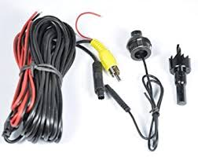

2.2 Software Interfaces
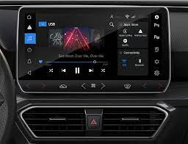
Here the software can be described as the trained model using the machine learning and data science technology. We also use python as well as its certain libraries such as NUMPY, PANDAS, SKLEARN, MATPLOTLIB, SEABORN, TENSORFLOW, KERAS, PYTORCH and to communicate with the database we can use SQLITE3 and connect it to localhost application. We use ANACONDA NAVIGATIOR which provide various application such as JUPYTER NOTEBOOK, PYCHARM and many more for Data science and machine learning applications.

2.3 Communications Interfaces
Communication interface is recognized by the display screen of the car, which will feature as an output display of the output as well as an audio output, if that feature is made available in the system of the cars.

CHAPTER – 3

3.1 PROPOSED METHODOLOGY

1] A. Nikonorov, P. Yakimov, M. Petrov, Traffic sign detection on GPU using color shape regular expressions, VISIGRAPP IMTA-4, Paper 8
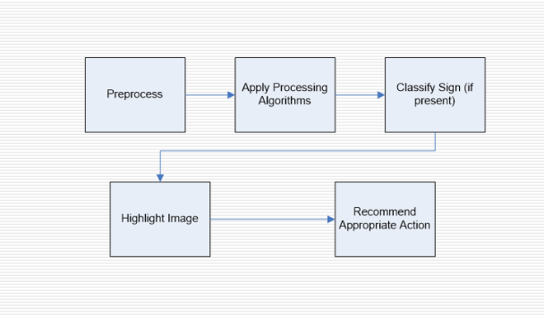
(2013).
[2] R. Belaroussi, P. Foucher, J.P. Tarel, B. Soheilian, P. Charbonnier, N. Paparoditis, Road Sign Detection in Images, A Case Study, 20th
International Conference on Pattern Recognition (ICPR), 2010, pp. 484-488

Fig 3.1- flowchart

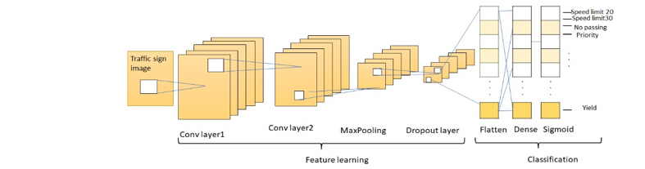
Fig 3.2- Structure of model

3.2 ALGORITHM
Convolutional neural network (CNN) :
A convolutional neural network, or CNN, is a deep learning neural network sketched for processing structured arrays of data such as portrayals.
CNN are very satisfactory at picking up on design in the input image, such as lines, gradients, circles, or even eyes and faces.This characteristic that makes convolutional neural network so robust for computer vision.
CNN can run directly on a underdone image and do not need any preprocessing.A convolutional neural network is a feed forward neural network, seldom with up to 20.The strength of a convolutional neural network comes from a particular kind of layer called the convolutional layer.
CNN contains many convolutional layers assembled on top of each other, each one competent of recognizing more sophisticated shapes.

Steps to Implement
- Sequentially add the layers in the order: two convolutional layers, one pooling layer, dropout layer, flattening layer, dense layer, again a dropout layer and finally the dense layer.

- In the convolutional layer, number of filters is specified. It performs the convolution operation on the original image and generates a feature map.

- The ReLU performs the maximum function to convert the negative values to zero without changing the positive ones and generate a rectified feature map. The Pooling layer takes the rectified feature map and performs a down-sampling operation (like Max Pooling or average pooling) and thus reduces the dimensionality of the image.

- The flattening layer is used to convert the input feature map to a 1-dimensional array.

- The dropout layer is used to avoid over fitting by setting some of the input neurons to 0 during the training process. The dense layer, on the other hand, feeds all the outputs from the preceding layer to all its neurons and perform the matrix- vector multiplication (the row vector of the output from the preceding layer should be equal to the column vector of the dense layer), to generate a m-dimensional vector.

- After addition of the layers, the model is to be compiled (final step in the creation of model to define the loss function and apply optimization techniques) and assign the loss function as “sparse_categorical_crossentropy” and use the “Adam optimizer”. The reason for specifying this loss function is that the proposed system is a multiclass classification problem, where multiple classes are considered but one image belongs to exactly one class.

- Next, the model is trained using the training dataset, by passing the pre-processed images from the training dataset.
- Finally, the predictions on the test data are done using the trained model and the traffic sign name along with the class Id is shown as an output

CHAPTER-4

4.1 DIAGRAMS

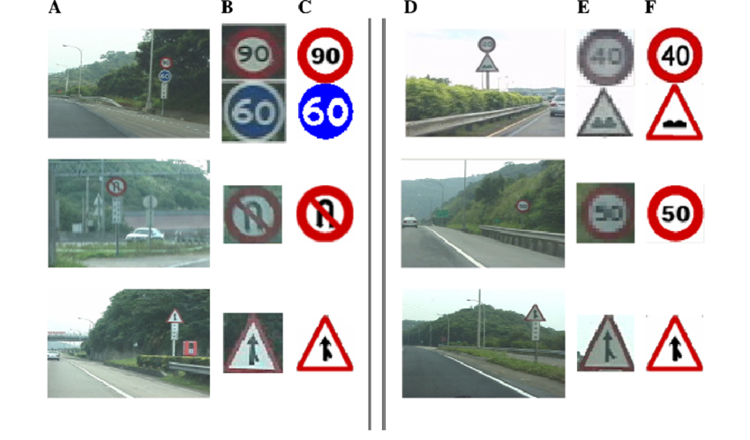
Fig 4.1- Experimental Results

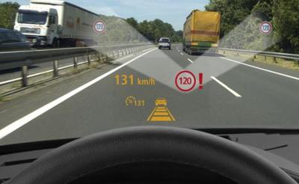
Fig 4.2 – Working of model

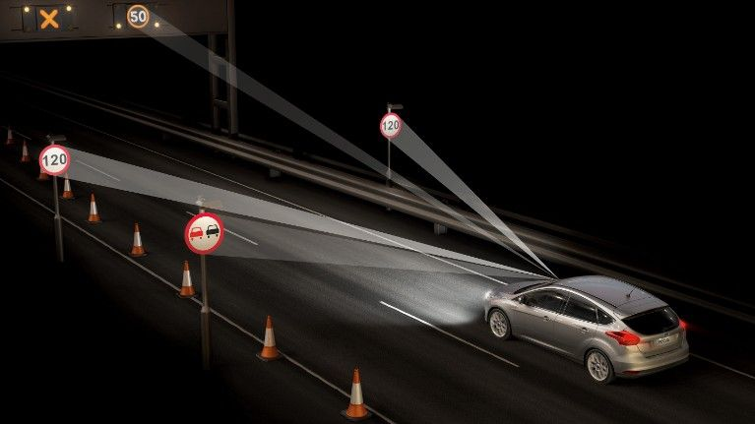
Fig 4.3- Demonstration of model in real life

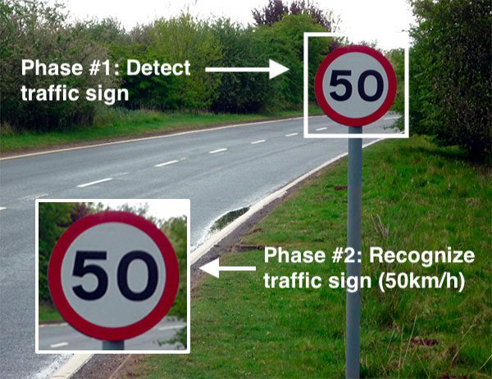
Fig 4.4 – Phases of working of model
CHAPTER -5
DFD LEVEL 0

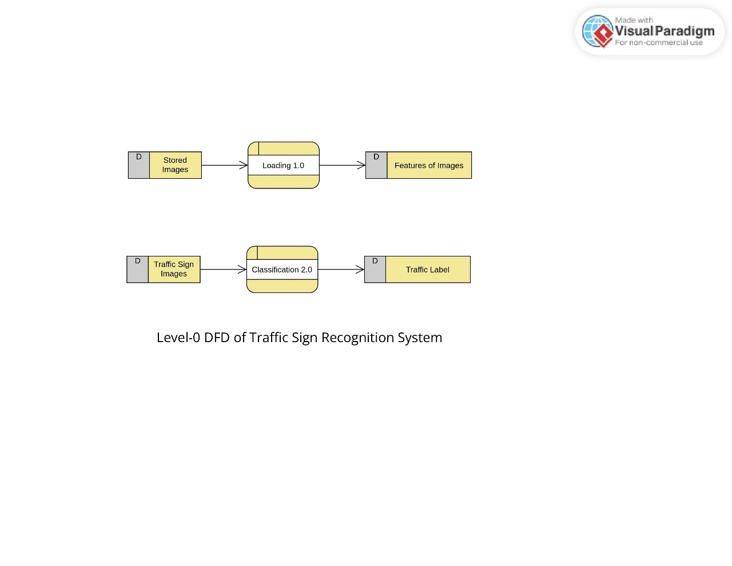

DFD LEVEL 1

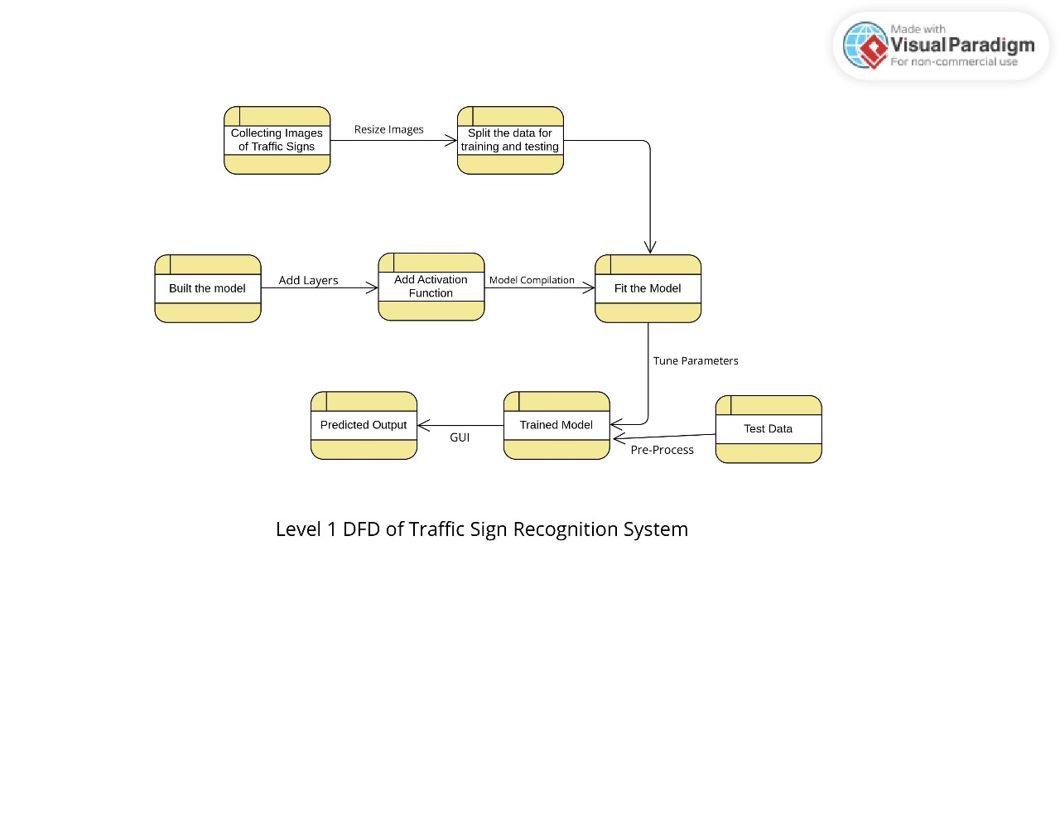

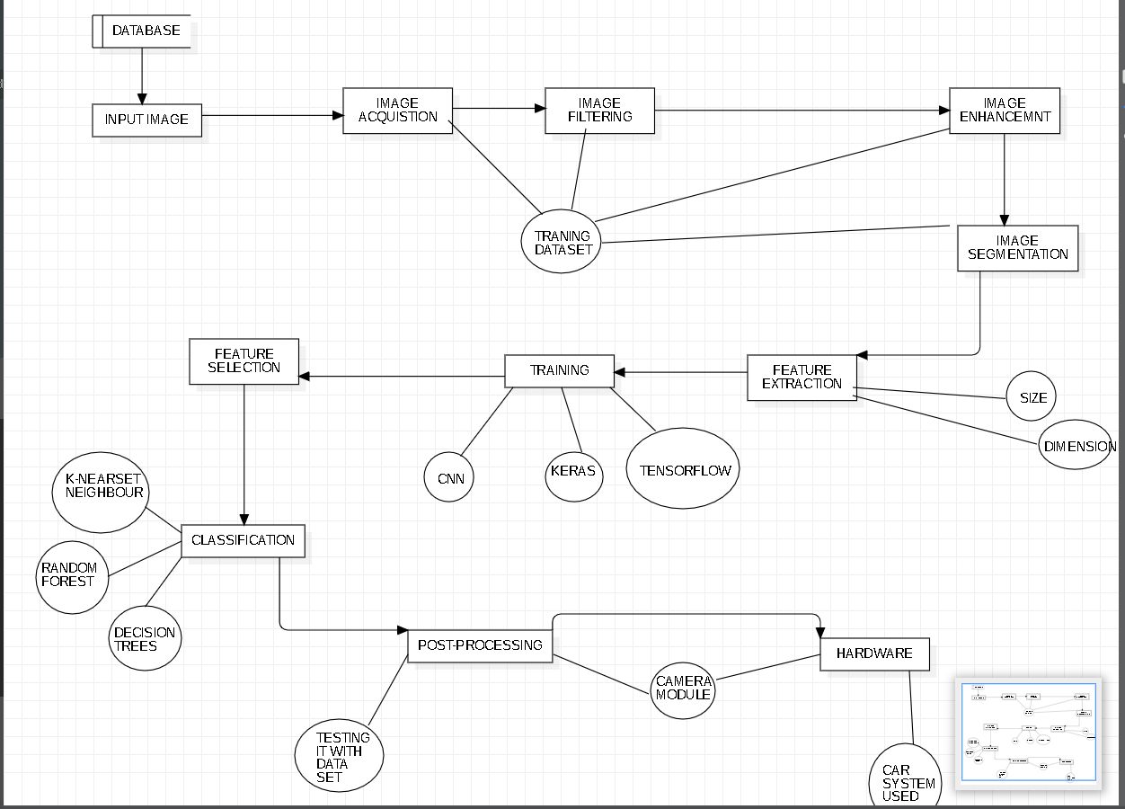
DFD LEVEL 2

ER Diagram
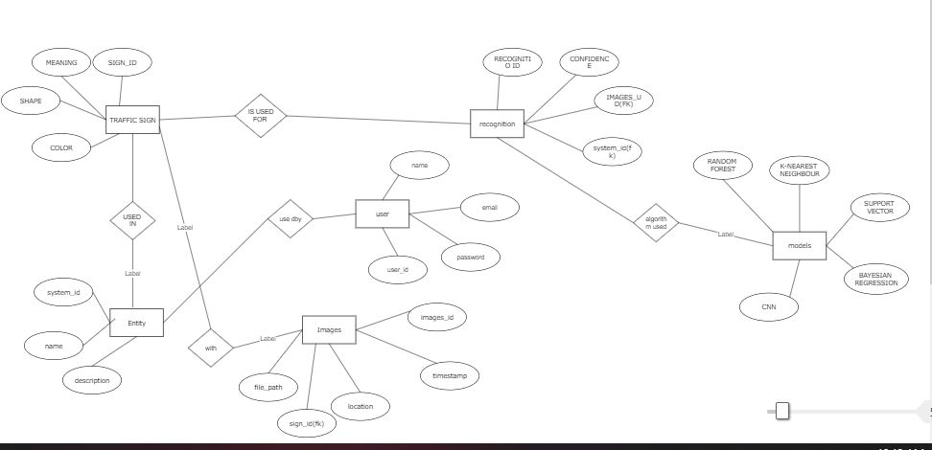

CHAPTER -6

5.1 CONCLUSION

The algorithm that has been used for traffic signs it can be generalized to deal with other kinds of objects. The known difficulties that exist for object recognition in outdoor environment have been considered. This way the system is immune to lighting changes, occlusions and object deformation being useful for driver support systems.
Due to this knowledge of the sign status, it is believed that the system is useful for other applications such as maintenance and inventories of traffic sign in highway and cities.

REFERENCES

[1] A. Nikonorov, P. Yakimov, M. Petrov, Traffic sign detection on GPU using color shape regular expressions, VISIGRAPP IMTA-4, Paper 8 (2013).
[2] R. Belaroussi, P. Foucher, J.P. Tarel, B. Soheilian, P. Charbonnier, N. Paparoditis, Road Sign Detection in Images, A Case Study, 20th International Conference on Pattern Recognition (ICPR), 2010, pp. 484-488
[3] Aditya, A.M., & Moharir, S. (2016). Study of Traffic Sign Detection and Recognition Algorithms.
[4] Mogelmose, M. M. Trivedi and T. B. Moeslund, "Vision-based traffic sign detection and analysis for intelligent driver assistance systems: Perspectives and survey", IEEE Trans. Intell. Transp. Syst., vol. 13, pp. 1484-1497, Dec. 2012.
[5] P. Viola and M. J. Jones, "Robust real-time face detection", Int. J. Comput. Vis., vol. 57, no. 2, pp. 137-154, 2004.
[6] L. Fletcher, N. Apostoloff, L. Petersson and A. Zelinsky, "Vision in and out of vehicles", IEEE Intell. Syst., vol. 18, no. 3, pp. 12-17, May/Jun. 2003
[7] S. Lafuente-Arroyo, P. Gil-Jimnez, R. Maldonado-Bascn, F. Lpez-Ferreras and S. Maldonado-Bascn, "Traffic sign shape classification evaluation I: SVM using distance to borders", Proc. IEEE Intell. Veh. Symp., pp. 557-562, 2005-Jun.
[8] V. Balali, A. A. Rad and M. Golparvar-Fard, "Detection classification and mapping of U.S. traffic signs using Google street view images for roadway inventory management", Vis. Eng., vol. 3, no. 1, pp. 15, 2015.
[9] K. C. P. Wang, Z. Hou and W. Gong, "Automated road sign inventory system based on stereo vision and tracking", Comput.-Aided Civil Infrastruct. Eng., vol. 25, no. 6, pp. 468-477, 2010.
[10] V. Balali and M. Golparvar-Fard, "Evaluation of multiclass traffic sign detection and classification methods for U.S. roadway asset inventory management", J. Comput. Civil Eng., vol. 30, no. 2, 2016

